Q1:

24=2^4 + 2^3 + 2^-3

Exp = 63 + 4 = 67 = 1000011

Fraction = 2^3 + 2^-3 => 10000010

Answer 1100001110000010

Q2:

- Keep the sign number.

- Flip all the bits (change 0 to 1 and 1 to 0).

- Add 1 to the number.

Hence, largest number in 8 bits: 01111111 = 2^7 - 1 = 127

Smallest number:

10000000 = (2^7 - 1) + 1 = 128

Q3:

33 (dec) = 100001(bin)

A={x, y, z, t, u, v} corresponding to the significant bits {2, 3, 5, 1, 0, 4}.

{z, v, y, x, t ,u}

=> A = zu

Q4:

unique elements is 2^10 = 1024

list of 0 elements is 1

list of 1 elements is 1<=3]024

list of 2 elements is 1024^2 = 1048576

list of 3 elements is 1024^3 = 1073741824

list of elements which is A <= 3 is 1+1024+1048576+1073741824 = 1074791425

The number of subsets of a set with n elements is 2^n

Answer the numbers of subset A <= 3 = 2^1074791425

Q5:

if c: => c is boolean

foo(x, 1, y) then 1 is passed to b in foo => b is integer

return a + b => a and b has same type => a is also integer. There is a case where a can be implicitly converted to integer is float.

x is passed to a => x is integer

y is passed to a => y is integer

Q6:

int A;

if (x == 2){

if y == z

A = x;

else:

A = y;

}

else A = z;

Q7:

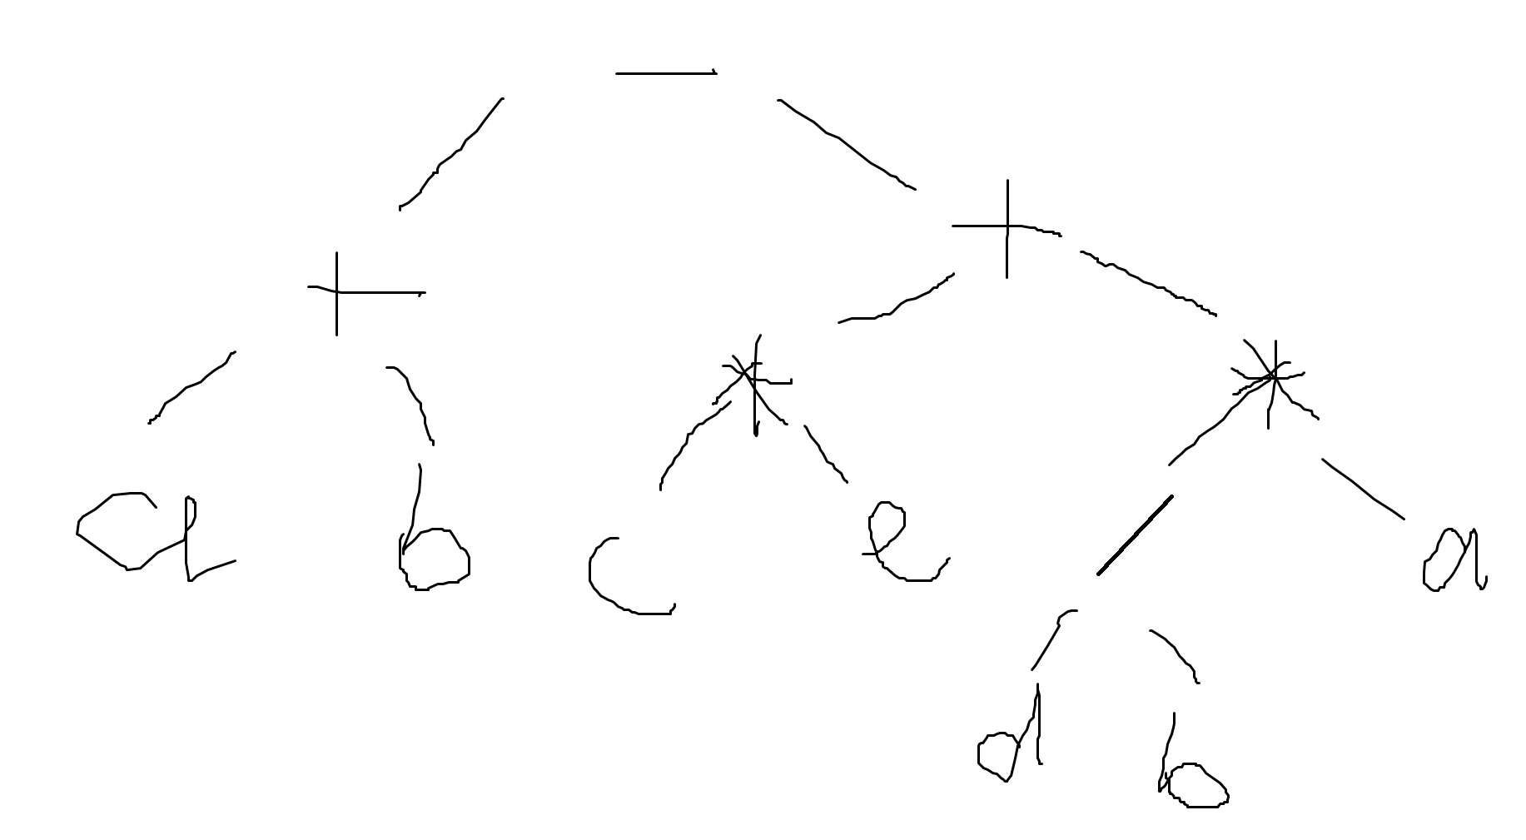

=> Prefix: - + a b + \* c e \* / d b a

=> Infix: a + b - c \* e + d / b \* a

=> Postfix: a b + c e \* d b / a \* + -

**Pre: - + a b + \* c e \* / d b a**

**In: ( a + b ) - (c \* e + d / b \* a)**

**Post: a b + c e \* d b / a \* + -**

Q8:

a - (b == 1)

true considered as 1, false considered as 0

Possible result: a - 1 if a == 1, else a;

a - (b = 1)

Since b = 1 returns 1

Possible result: a - 1

a + (a == 1)

Possible result: a + 1 if a == 1, else a;

a + (a = 1)  
Since execution is either left-associative or right-associative, a is calculated as a before or after the assignment

Possible result: a + 1, 1 + 1

(a = 1) || a

Possible result: true

Q9:

Else statement is activated whenever the boolean expression is false. This applied in if, while, for statements

Q10:

Continue will stop that iteration and start at the beginning of the loop.